Name: Date:
Computer Basics: Connecting to the Internet
- Which internet service do you think you have at home?
- Describe satellite service.
- What does ISP stand for?
- List 3 things you should consider when researching ISPs.
- Identify the Internet hardware below. Write the term and definition for each item.
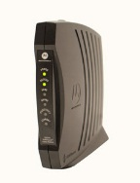
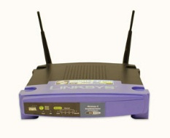
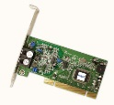

- Finish the sentence:
In a home network______________________________
- What is SSID?
- What is an encryption password?
- What are the steps you can do to setup a home network?
- Complete the “Challenge” on slide 7:
Challenge!
- Research two or more Internet service providers (ISPs), and compare their service packages. What are the different connection speeds offered by each provider?
- Try using a few different web browsers. Do they work differently? Which one was easier to use?
- Do you have any devices (computers, mobile phones, etc.) that can connect wirelessly? Would it make sense to create a wireless network in your home?

