Intro IT Classwork: Lesson 2

Folksonomy is the practice of categorizing online content through tags for non-technical users.
- The tags themselves can consist of keywords, category names or metadata.
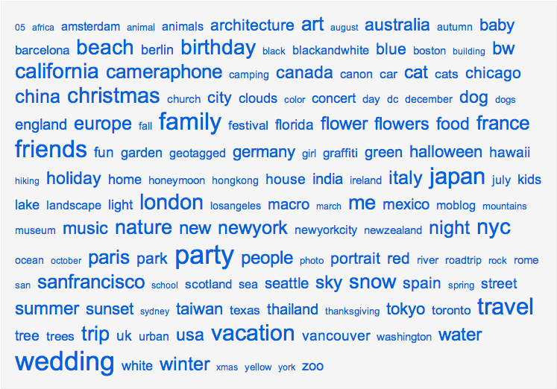 Example

- Come up with 5 words for this classes webpage using folksonomy (Intro IT page)
1
- Pick your favorite artist and come up with 5 words using folksonomy for their website
- Pretend you designed a website for your mother, father, or guardian; come up with 5 words using folksonomy for their website

Read pages 2-8 through 2-12 in your text book wrote 2 facts about each section listed below:
2

Podcast
Semantic Web
Mashup
Social networking
Privacy and responsibility on social networking sites

3
- Give 3 examples of social networking sites.
- Give 3 examples of websites you never heard of.

